Subramani P

21/11/2024

Pl/SQL task-3

Cursor& procedure,views

alter table emp add column DOJ date;

select * from emp;

update emp set DOJ = '2014-12-11' where emp_id = 101;

update emp set DOJ = '2010-02-01' where emp_id = 102;

update emp set DOJ = '2013-11-11' where emp_id = 103;

update emp set DOJ = '2018-05-23' where emp_id = 104;

update emp set DOJ = '2019-12-11' where emp_id = 105;

update emp set DOJ = '2020-12-09' where emp_id = 109;

update emp set DOJ = '2018-06-11' where emp_id = 110;

update emp set DOJ = '2018-07-11' where emp_id = 115;

update emp set DOJ = '2018-09-11' where emp_id = 116;

update emp set DOJ = '2018-07-13' where emp_id = 117;

-- write the procedure that returns the details of employees joins in specific year(execute details (2020))

delimiter //

create procedure get_specificYearDatails(in get_year int)

begin

select * from emp where year(DOJ) = get_year;

end; //

call get_specificYearDatails(2020);

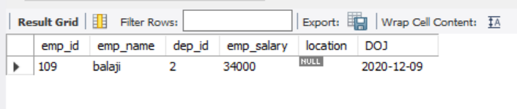

-- create a view that display the details of senor most person

create view senior_view as

select * from emp order by DOJ asc limit 1;

select * from senior_view;

